|  |
| --- |
| DMIT2590 – Capstone |
| NAIT Pathways System Documentation |
|  |

|  |
| --- |
| Team 5K:  Xin Du, Yang Liu, Kyle Gibson, Ashley Condie, Briand Rabideau  Instructor: Gerry Schenk  Section: A03 |

Table of Contents

INTRODUCTION 2

***1.1 About NAIT Pathways*** 2

***1.2 System Roles*** 2

SYSTEM WALKTHROUGH 3

***2.1 Administrator*** 3

***2.2 Student*** 10

KNOWN BUGS / ISSUES 13

SUMMARY AND RECOMMENDATIONS 14

***9.1 Summary*** 14

***9.2 Recommendations*** 14

GLOSSARY 15

# INTRODUCTION

## 1.1 About NAIT Pathways

NAIT Pathways is an application that assists current and prospective students in selecting the program that is right for them .The system allows a user to enter their education and preferential information, which will result in a list of programs that might be a good fit and any credits they may be eligible to receive. Furthermore, the system allows NAIT staff to add entrance requirements, preference question parameters, course equivalencies, and other parameters that will allow the system to properly match programs.

## 1.2 System Roles

The system contains two primary user roles that differentiate the amount of information displayed and the level of interactivity the user can access.

**Administrator**

The administrator is responsible for maintaining a wide range of courses and peripheral course information that is essential for the system to correctly find program matches for non-admin users. This is accomplished through a variety of menus that allow the administrator to modify program information, course information, entrance requirements, course equivalencies, and so on. This role will be assigned to a single user account where the login information can be provided to staff at NAIT’s discretion. All of the administrator pages will be covered in depth in the walkthrough section.

**Student**

The student only has access to academic pathways searches, which is the primary function of the system. They will be asked to provide their academic profile, including high school and post-secondary courses, and their preferences for a potential career. Based on the data provided the system will then sort through the programs in the database and attempt to find the best possible matches for the student. These results are displayed in a list that give a brief description of the program, the percent match to the student’s preferences, any credit they may receive from previous courses, and a link to the program page on the NAIT website.

# SYSTEM WALKTHROUGH

## 2.1 Administrator

The administrator has access to a wide variety of content management pages that will have a direct influence on the functionality of the NAIT Pathways system. They are as follows:

1. **Admin landing page** – this is the umbrella page that the administrator will see upon logging in and provides access to the wide variety of admin actions.  
     
   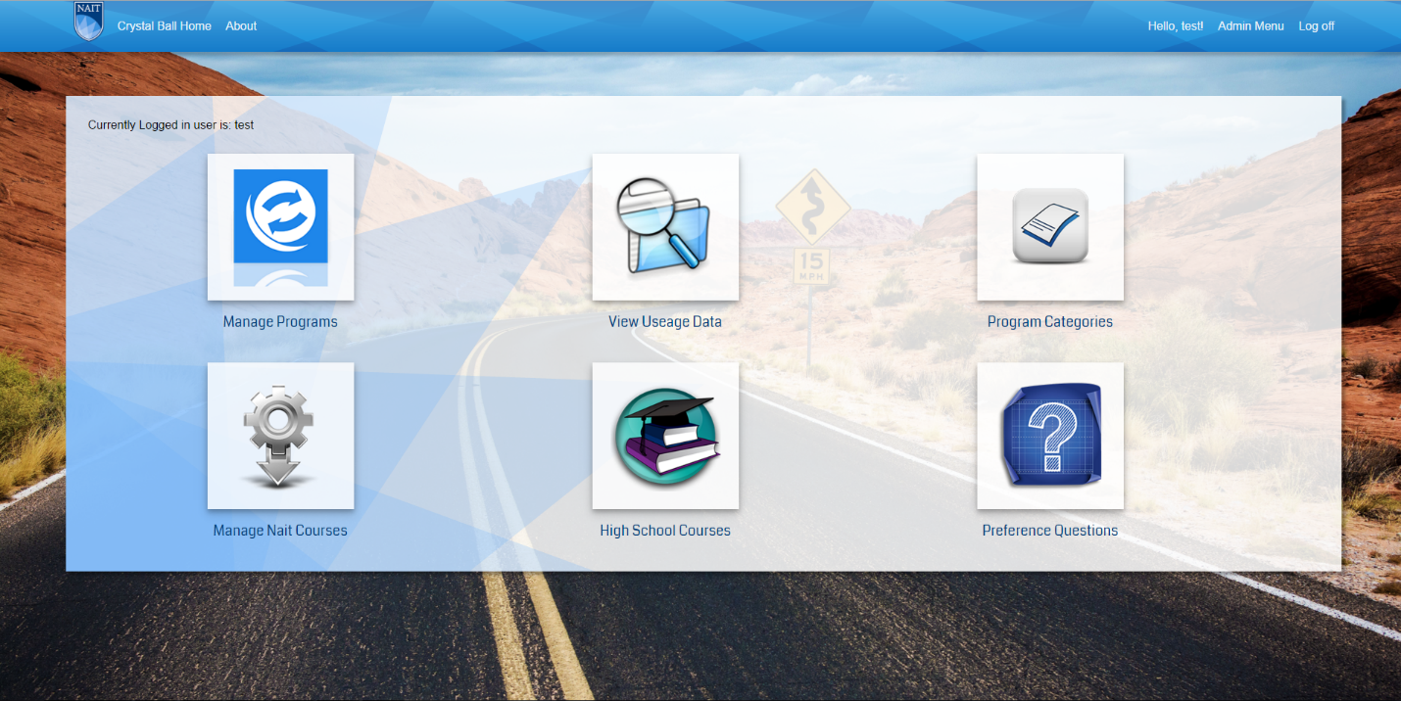
2. **Manage programs** – This page allows the administrator to manage programs including adding and updating. This section is comprised of the following sub-sections:
   1. *Search Programs* – The administrator can search for a specific program or lookup all programs in a specific category. Clicking edit on a program will open the manage programs page.  
        
      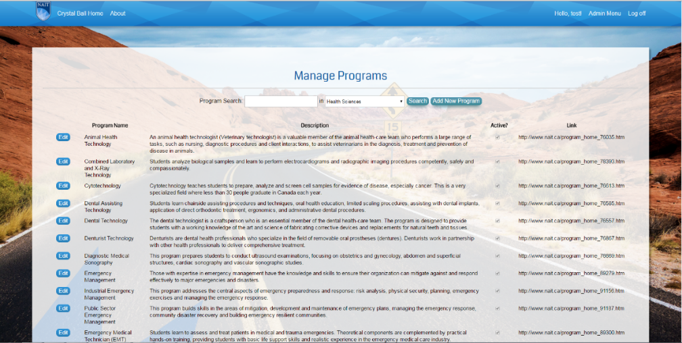
   2. *Manage Programs – Step 1: Manage Program Information* – The administrator can update the profile information including name, credential type, description, total credits, etc.  
        
      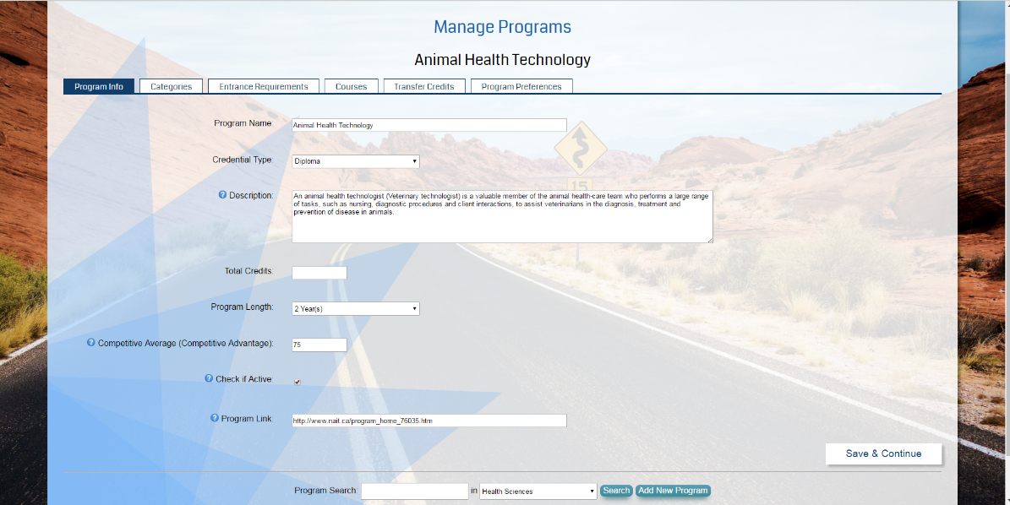
   3. *Manage Programs – Step 2: Set Program Category* – The administrator sets the program categories that the program belongs to. This will affect search results and how the program is retrieved in drop down lists.  
        
      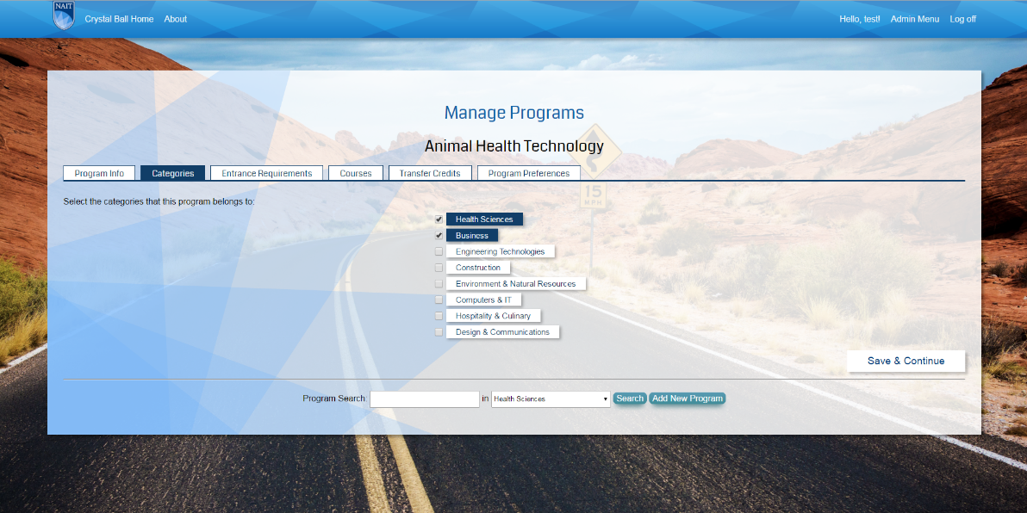
   4. *Manage Programs – Step 3: Set Program Entrance Requirements* – The administrator sets the entrance requirements for the program including high school courses and post-secondary courses (if relevant).  
        
      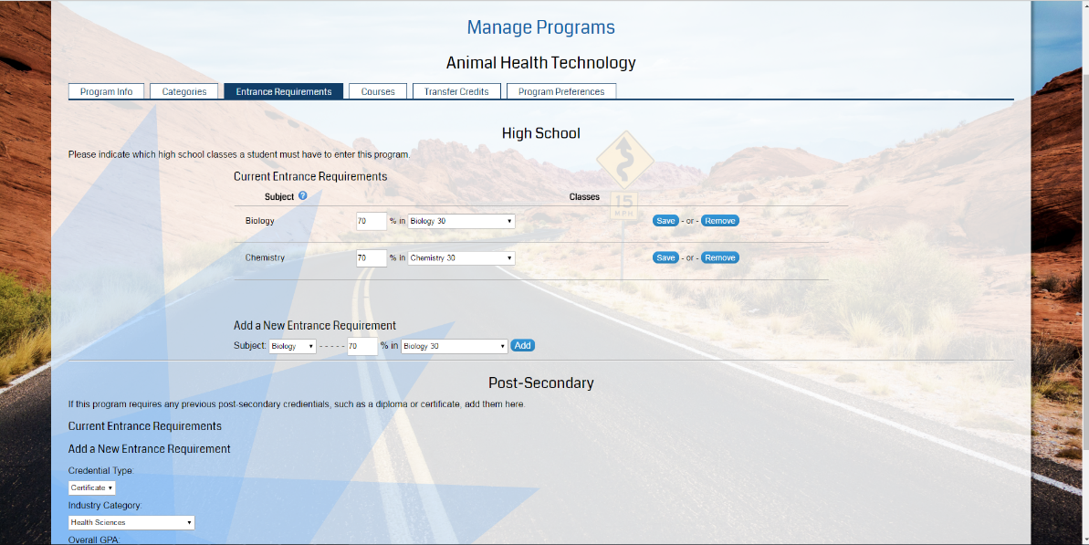
   5. *Manage Programs – Step 4: Add Program Courses –* The administrator sets what courses are part of the program.  
        
      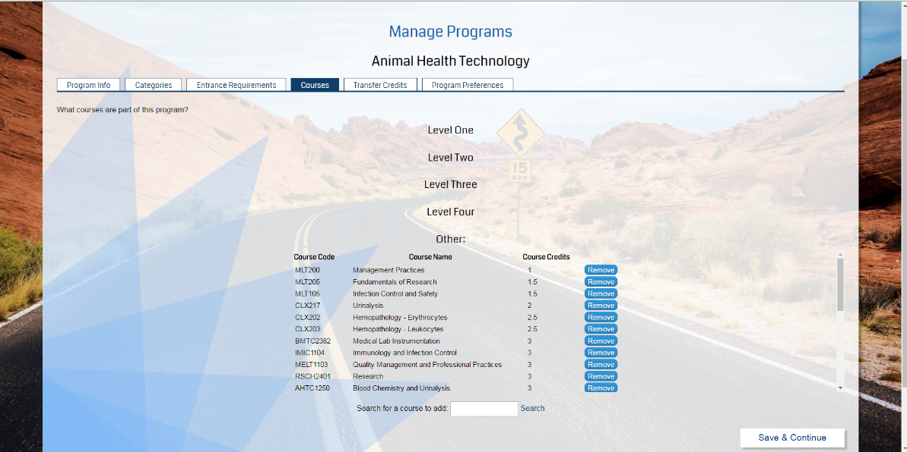
   6. *Manage Programs – Step 5: Set Transfer Credits* – If relevant, the administrator sets what courses are eligible for transfer credit and which courses provide said credit.  
        
      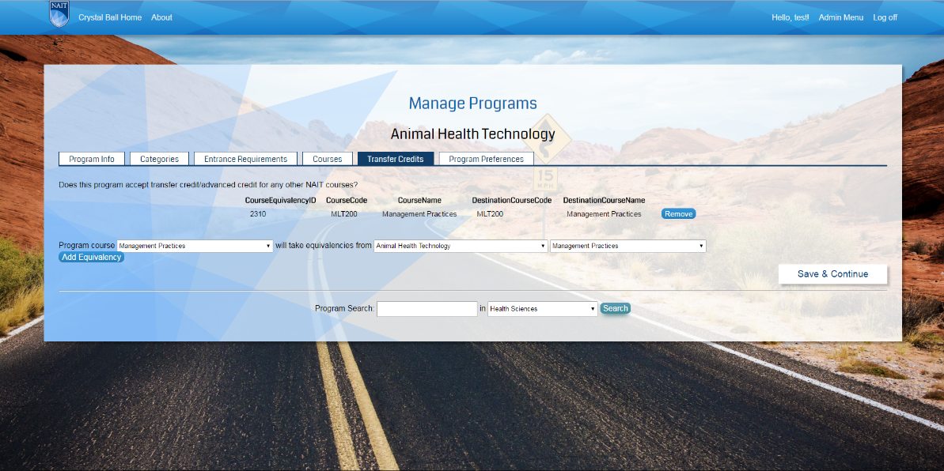
   7. *Manage Programs – Step 6: Set Program Preferences* – The administrator will set the expected program preferences that will result in a positive match between a prospective student’s preferences and the program preferences.  
        
      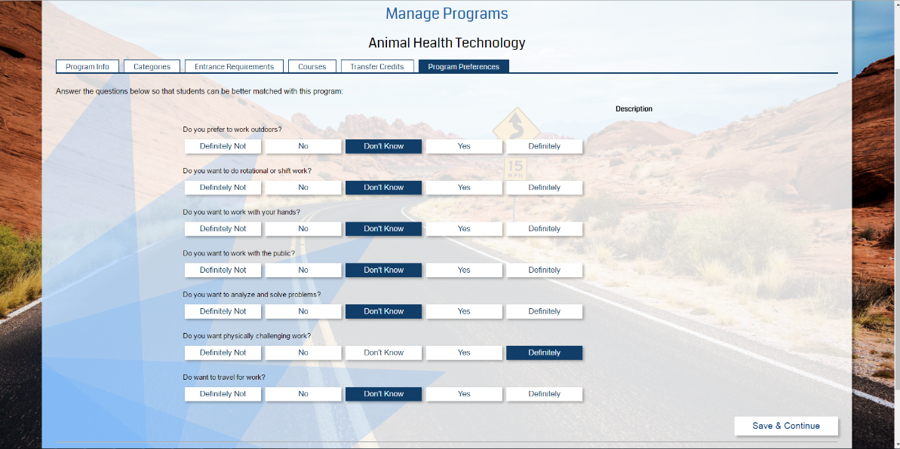  
        
      Once the administrator is satisfied with the parameters set for a particular program they can then be saved, which will update the database entry for that program.It should be noted that any changes made to a program are saved to the database whenever the user moves to another step.
3. **Reporting (View Usage Data)** – This section allows the administrator to generate reports relating to metrics gathered by the system as it searches for results. This is broken into two sections:
   1. *Program Data –* This tab allows for generating reports relating to student metrics including the frequency a program was a search result, the percent of students who want to switch programs, and the type of program a student is currently enrolled in. The report generated is sorted by date and can be exported to a PDF.
   2. *Student Data –* This tab generates metrics based on the preference questions that were answered by students and aggregates all answers into a percentage. This data is sorted by date and provides details including the student’s semester (if applicable), change program status, and the percentage of answers provided to each preference question.
4. **Manage Categories –** This section allows for adding or updating the umbrella categories that programs will be a part of. Categories cannot be deleted as it is necessary to maintain outdated categories in case a prospective student has credit in a discontinued program.  
     
   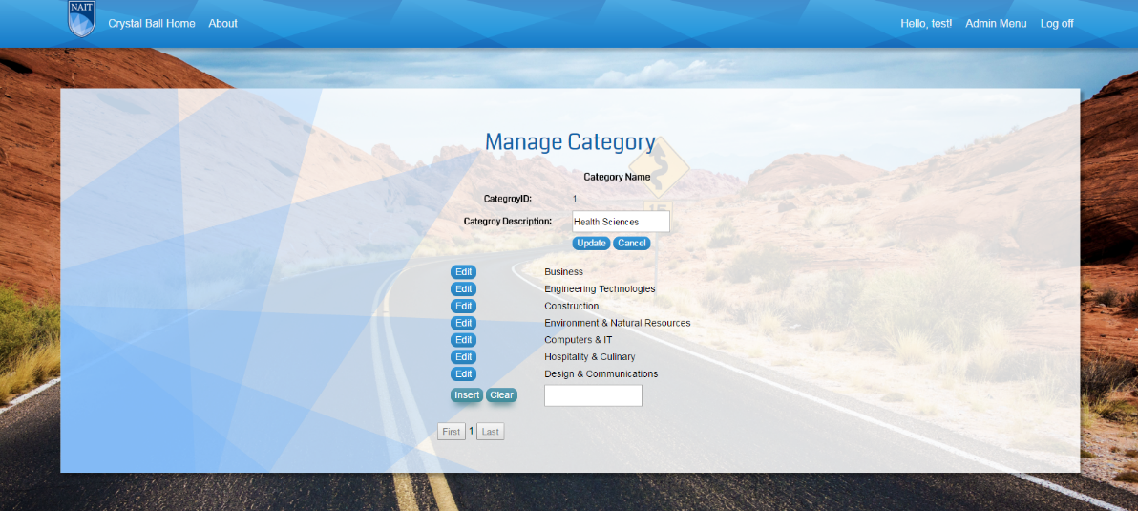
5. **Manage NAIT Courses –** This page allows the administrator to search for NAIT programs based on category and can modify existing programs or add new ones. When modifying or creating a program, the administrator is expected to provide a course code, course name, credit value, and whether the course is active or not.  
     
   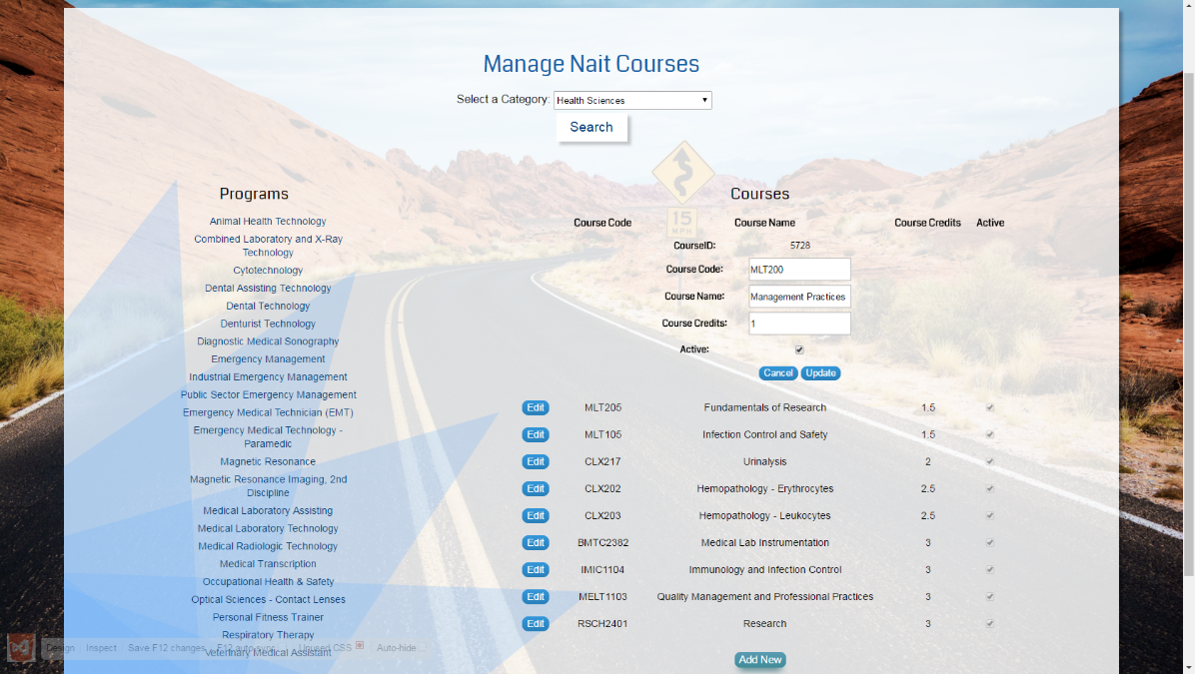
6. **Manage High School Courses** – This section allows the administrator to modify or add high school courses to the database. In addition to the course name, it is essential to provide the course category (Math, Science, etc.) and high school level of each course (1, 2, 3).  
     
   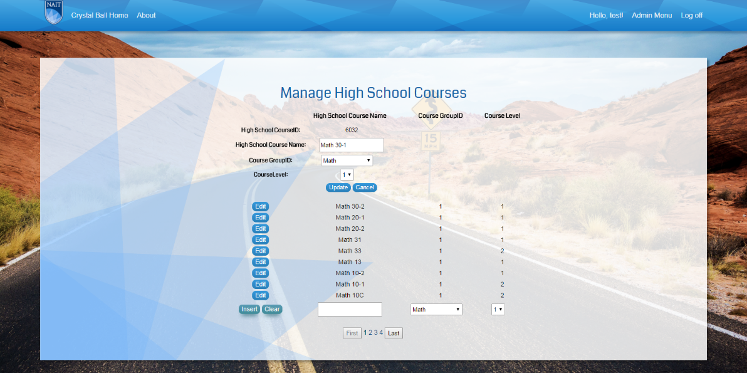
7. **Manage Preference Questions** – This section allows the administrator to add or modify preference questions stored in the database. The question IDs are automatically generated by the database but the user is expected to provide the question description and whether it is active or not.  
     
   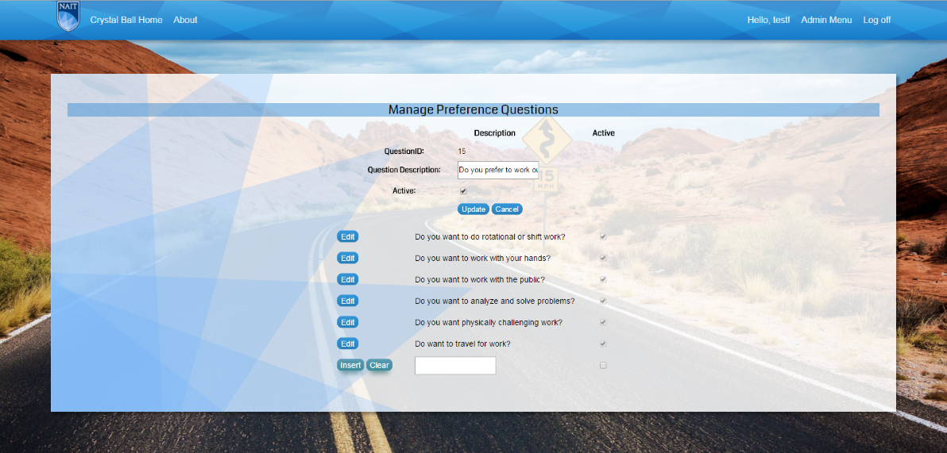

## 2.2 Student

Any user that does not log in will be considered a student and will only have access to the pathways search engine. When the search is initiated it will prompt the student for education and preference information through a series of steps, which are as follows:

1. **Select High School Courses (Optional)** – This page prompts the user to provide the high school courses they have taken and whether or not they have graduated from a post-secondary institution. This section will filter out courses where the user does not meet the high school entrance requirements, however it can be left blank and still retrieve results.  
     
   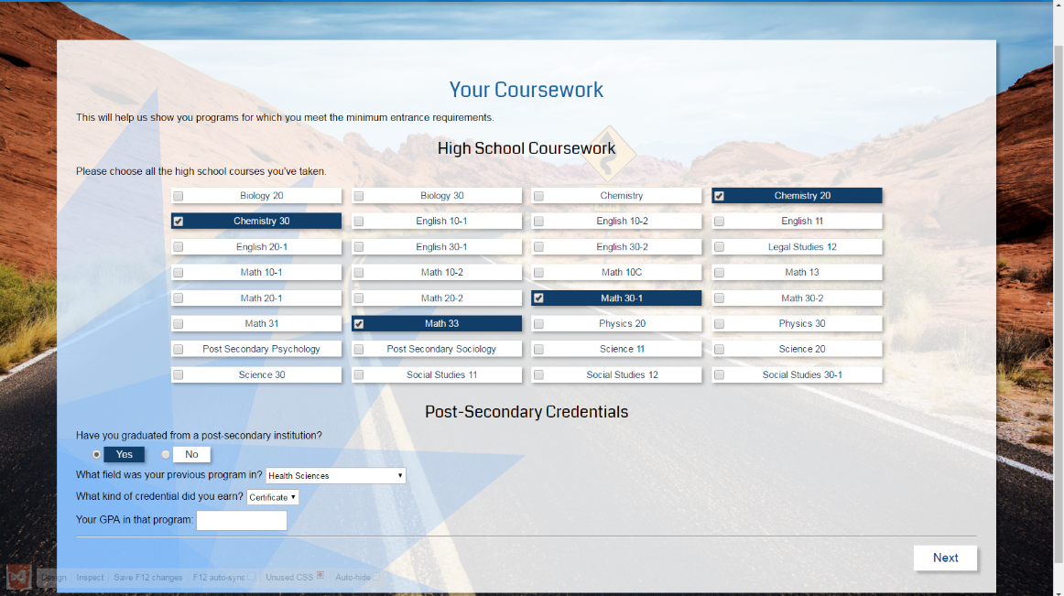
2. **Provide NAIT Education Background (Optional)** – If the user tells the system they are a NAIT student they must provide the program they are enrolled in, their semester, and whether they would like to switch programs. The system will autofill the core courses of the program they selected in the next step.  
     
   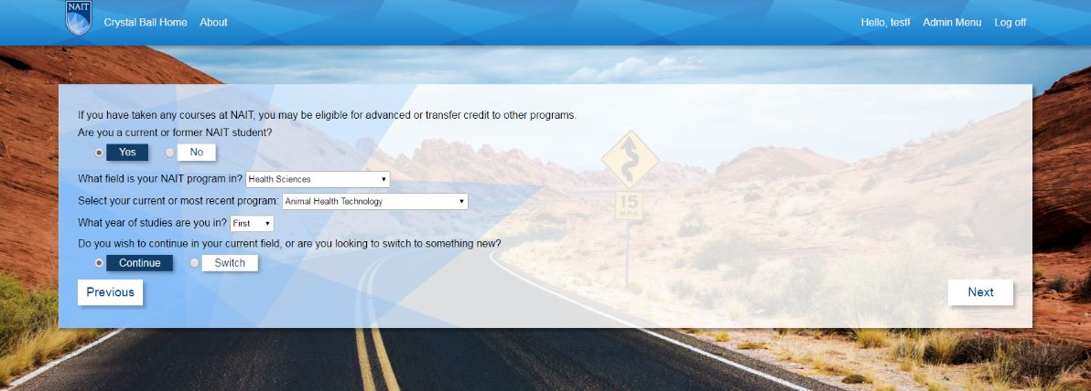
3. **Select NAIT Courses (Optional)** – If the user has indicated they are a NAIT student their course basket will be automatically filled with the core courses of the selected program. This section also allows the user to search for NAIT programs and add them to the course basket. This page will log the amount of courses that are selected and provides the option to delete individual courses from the basket or empty it entirely. The page is skipped if the user indicates they are not a NAIT student.  
     
     
   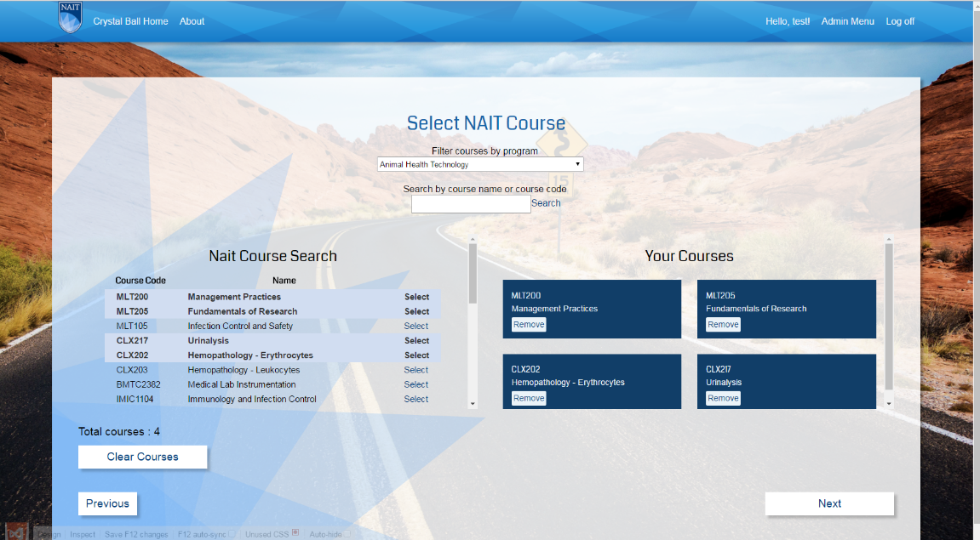
4. **Answer Preference Questions** – The user is prompted to answer a series of preference questions that will filter down the possible search results that will be displayed by the system. This section is technically optional but will default all answers to “neutral.”  
     
   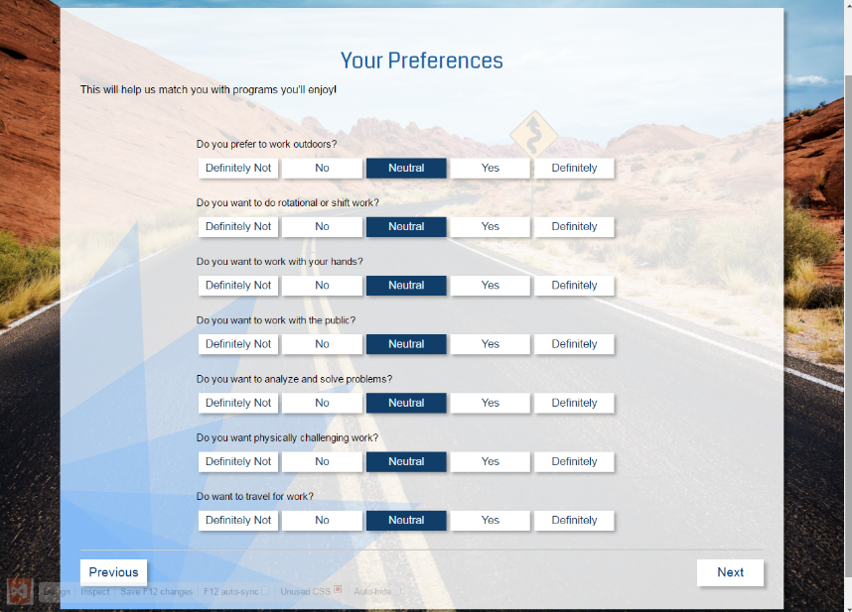
5. **Results Display** – After completing (or skipping) the other sections the system will search the database for possible matches and display them to the user. The system will also display the percent match based on the user’s responses and the transfer credit they may be eligible to receive. The user can then opt to view the NAIT webpage for each of the programs listed or search again.  
     
   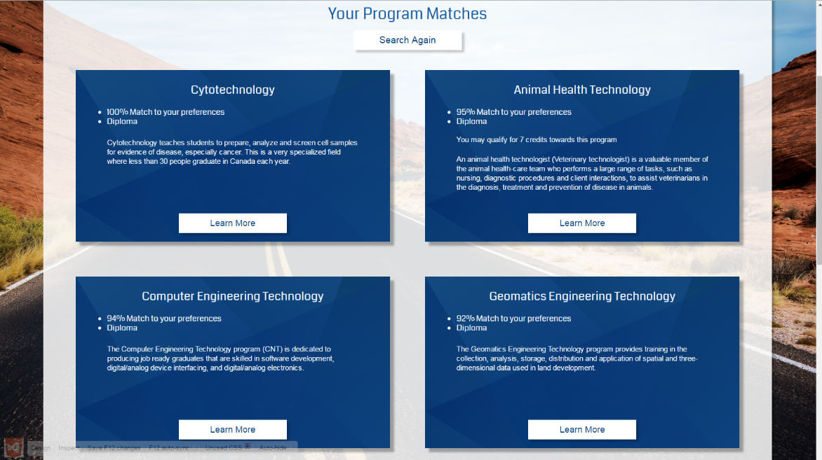

# KNOWN BUGS / ISSUES

* The program hangs for several seconds while it retrieves a list of academic pathway results. This is compounded by database size and speed of the server used.

# SUMMARY AND RECOMMENDATIONS

## ***9.1 Summary***

The NAIT Pathways system is a robust application that allows a prospective student to efficiently determine the academic pathways available to them, and allows administrators to easily set matching parameters. Through effective management of programs by NAIT staff, the system will reliably return results that align with a student’s preferences and academic qualifications. Should more features be desired or an upgrade be necessary the system has been designed in a modular fashion to allow for easy modifications.

## ***9.2 Recommendations***

Should the client decide to move forward with this project and implement phase III, a framework will need to be added that allows third party institutions access to this application. This will allow other educational institutions to implement a similar program to NAIT Pathways and provide NAIT the opportunity to provide transfer credit estimates for post-secondary courses from other institutions. It would also be beneficial to add a password recovery system as the program currently does not utilize one. Currently the password can only be reset through the SQL database by changing the password to a known value. Implementing a password recovery feature will vastly improve the user experience should this service need to be utilized.

# GLOSSARY

**A**

Administrator – A user that has full access privileges to modify information stored by the system.

**C**

Category – A category is a descriptor that groups a set of programs based on their field or discipline. (Eg. Health Sciences, Computers and Technology, etc)

**P**

Pathway – A possible academic route that is available to a student based on the information they provide to the system.

Program - an educational program at NAIT where a student is working towards a specific educational goal, such as a degree or diploma.

**S**

Student – A student is by default a user with not administrator privileges. They are limited to searching for academic pathways.

**U**

User – A user is an individual that interacts with the system and can either be a prospective student or NAIT administrator.